# **Name: Abdurrahman Qureshi**

# **Roll No: 210451**

Practical No: 31N32

**1)** **WAP to copy characters from one file to another**

**CODE:**

import java.io.*;

public class CopyFile {

public static void main(String[] args) {

String inputFile = "whereShouldIGo.txt";

String outputFile = "getOverHere.txt";

try {

FileInputStream inputStream = new FileInputStream(inputFile);

FileOutputStream outputStream = new FileOutputStream(outputFile);

int data;

while ((data = inputStream.read()) != -1) {

outputStream.write(data);}

inputStream.close();

outputStream.close();

System.out.println("File copied successfully.");

} catch (IOException e) {

e.printStackTrace();}}}

**OUTPUT:** 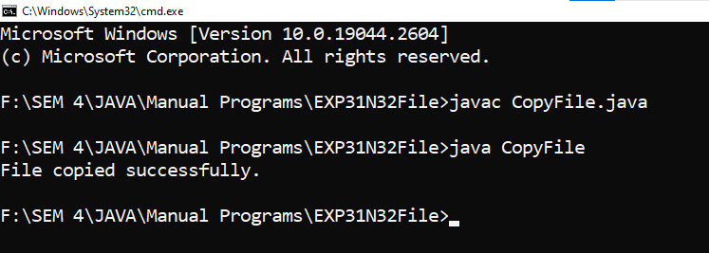

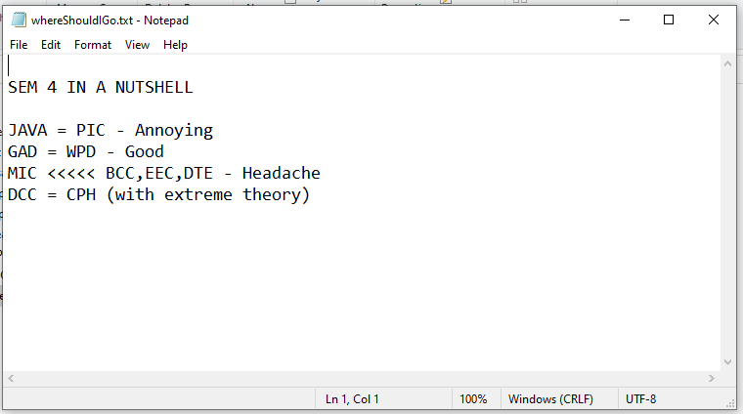 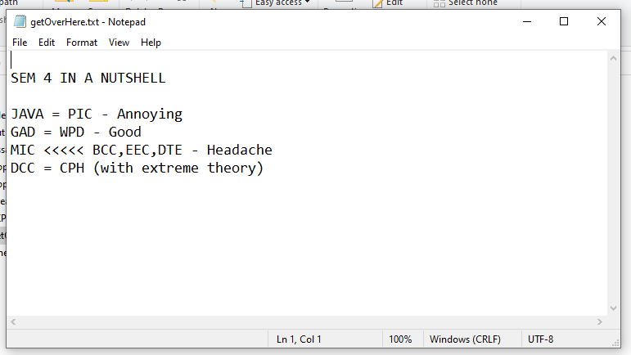

**2)** **WAP to read a data from a file using character stream**

**CODE:**

import java.io.*;

public class ReadFile {

public static void main(String[] args) {

String inputFile = "whereShouldIGo.txt";

//String outputFile = "getOverHere.txt";

try {

FileReader fr = new FileReader (inputFile);

BufferedReader br = new BufferedReader(fr);

// FileOutputStream outputStream = new FileOutputStream(outputFile);

String data;

while ((data = br.readLine()) != null) {

int i = 0;

if (i == 5) {

System.out.println(); }

System.out.print(data );

i++;}

fr.close();

br.close();

//outputStream.close();

System.out.println("\n\n\tFile copied successfully.");

} catch (IOException e) {

e.printStackTrace();}}}

**OUTPUT:**

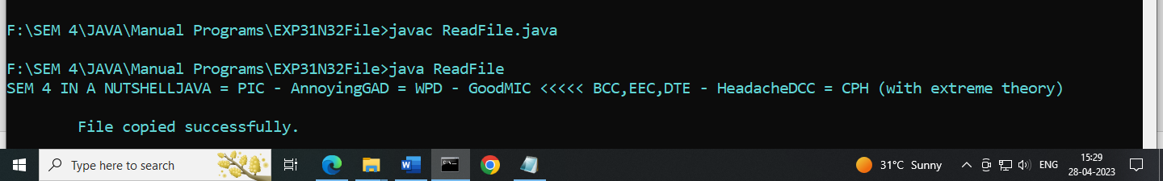

**3)** **WAP to write a data in a file using character stream**

**CODE:**

import java.util.*;

import java.lang.*;

public class ExamInterface{

public static void main(String[] args) {

Result R = new Result(42,89,91,88 ,"SattarBaksh");

R.display_res();}}

class Student {

protected String name;

protected int id;

Student(int i,int j , int k , int l,String n) {

id = i; name = n; }

void display() {

System.out.println("Age of Student \t\t: " + id);

System.out.println("Name of Student \t: "+ name); }}

interface Exam {

// int basic_salary = 75000;

public void percent_cal(int i , int j, int k, int l); }

class Result extends Student implements Exam{

protected int total = 0;

protected int p = 0;

Result( int i ,int j , int k , int l,String n ) {

super(i,j,k,l,n);

percent_cal(i,j,k,l);

total = i+j+k+l; }

public void percent_cal(int i , int j , int k ,int l) {

double p = (float)(i+j+k+l)/400*100;

System.out.println("Perecentage \t\t: " + p); }

void display_res() {

super.display();

System.out.println("Total Marks \t\t: " + total); }}

**OUTPUT:**

